Automatic multiple zebrafish tracking based on improved HOG feature
Yun-Xiang Bai^{1●}, Shu-Hui Zhang^{2●},Zhi Fan¹, Xing-Yu Liu², Xin Zhao¹, Xi-Zeng Feng^{2*}, Ming-Zhu Sun ^{1*}
¹Institute of Robotics and Automatic Information System, Nankai University, Tianjin 300350, China.
²State Key Laboratory of Medicinal Chemical Biology, College of Life Science, Nankai University, Tianjin 300071, China.

● These authors contributed equally to this work.
* sunmz@mail.nankai.edu.cn (MZS); xzfeng@mail.nankai.edu.cn (XZF).

Supplementary Text S1
Supporting information
Dataset S1 Raw video and tracking results data of 16 zebrafish.
(ZIP)
Text S1 Methodological details.
(DOC)
Video S1 Tutorial of 6 zebrafish tracking result.
(WMV)
Video S2 Tracked result of 16 zebrafish.
(AVI)

Zebrafish patch collection
Experiments show that when the fish body has a large bending during swimming, it will affect the global correctness of the back texture of the fish and cause the difference of the further output HOG feature and ultimately affect the correct classification result (Figure 1 and Figure 2). Therefore, we calculate the target external rectangle aspect ratio threshold, excluding the case where the fish body was significantly deformed.
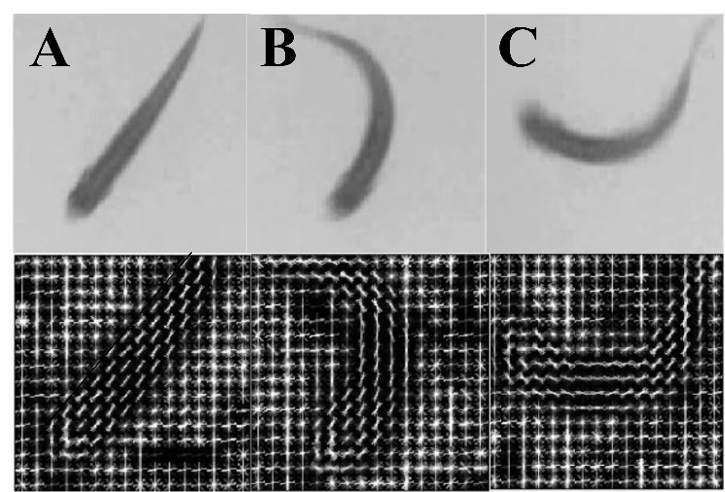
Figure 1. The contrast HOG feature of normal and deformed zebrafish. (A) The HOG feature of normal zebrafish body is concise and regular. (B-C) The HOG feature of deformed zebrafish body is disorganized.
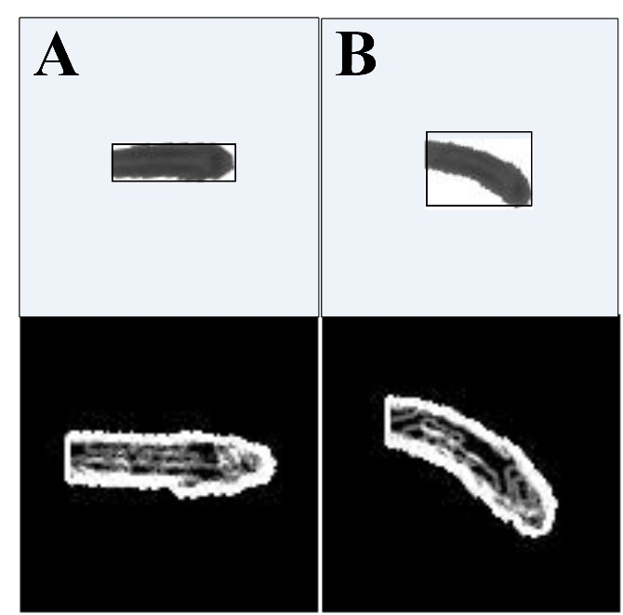
Figure 2. The contrast HOG feature of normal and the example with aspect ratio larger than the threshold. (A) The HOG feature of normal zebrafish head is regular. (B)The HOG feature of example with aspect ratio larger than the threshold is disorganized.

Tracking system
The tracking system, which is based on the improved Histogram of Oriented Gradient (HOG) feature, provides the easy-to-use graphical user interface and the manual error correction function to increase the correctness of the final trajectories. The GUI interface is shown as Figure 3. The display interface is on the left, displaying the target center coordinates over the last 20 frames, as well as the initial image sequence; the function panel on the right side is divided into three parts: the Detection Zones, the Tracking Zones and the Results viewing Zones. The detail functions are as follows:
1、The input video is selected by the Load videos button.
2、After calculating the background model, the area threshold and the gray threshold were set for the background subtraction.
3、Previous and Next buttons enable single frame adjustment and positioning of the video.
4、Click the Binary image button to view the background subtraction result, then adjust the value of threshold to determine the optimal parameters.
5、Click the Save parameters button to save the number of targets and the parameters of threshold.
6、There are off-line and on-line modeling mode in the Tracking Zones, and in this paper we applied the on-line mode, needless to pre-shooting the single zebrafish in advance.
7、Click the Tracking button to obtain the final trajectory.
8、The Display trace button and Hide trace button can convert to each other.
9、Click the Pause button to suspend the left result display.
10、The Checkbox can select the fish to add the markup of trace and display on the left interface.
11、Manual correction • OFF button and Manual correction button, as well as the Link trace button can be click-converted by the mouse.
12、The tracklets belonging to different identity with lower confidence are located.
13、Adjust the orders of frames by the Previous and the Next buttons to confirm whether the error occurs. Then click the Accept button to automatically locate the next possible error point.
14、OK button to confirm the manual correction, Cancel button to cancel the current operation.
15、The Message pane displays the message of command windows to remind the user of the current process.
16、The display interface displays the multi-targets trajectory over the last 20 frames.
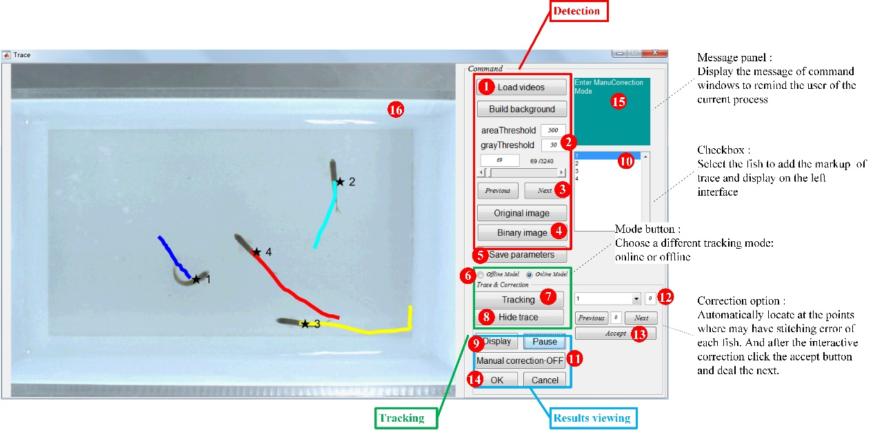
Figure 3. Multi-target tracking platform GUI

Manual correction function:
Manual correction • OFF button and Manual correction button, as well as the Link trace button can be click-converted by the mouse.
In the Manual correction button function, the left interface displays the trajectory of the targets in the past 20 frames and the next 3 frames based on the current frame. As the low confidence trajectory occurred in the crossing intervals, it is difficult to get the tracklets location by clicking mouse. Thus the start nodes and end nodes of the tracklets are marked with different symbols, then the mouse clicking can be easily carried out during the manual correction.
In the process of manual correction, the tracklets belonging to different identity with lower confidence are located in the lists. By selecting the different target IDs, the tracklets with lower confidence are located, and adjusting the orders of the frames by the Previous and the Next buttons to confirm whether the error occurs. If the tracklets with low confidence but with no matching error occurs, click the Accept button to automatically locate the next possible error point. If there is a matching error in the current frame, manual correction is performed. Use the right click of mouse to click on the fish body region or tracklets node points of tracklets before and after the crossing intervals, then the tracklets can be manual matched correctly. OK button to confirm the operation, Cancel button to cancel the current operation. Above all, manual error correction is implemented for all tracklets that may have the matching error.
Link trace function deals with the non-matched tracklets, in which the tracklets have not been matched due to the timing relationship after the algorithm is processed. Adjust the video frame before and after to select the matching target, then the process just as the manual error correction.

Multi-target identifying
To further verify the adaptability of the improved HOG feature, we also identified the drosophila (ISO4) and the black mouse (C57 B6) in the multi-target identifying experiment, in which drosophila wings were subtracted to be convenient for the sample images acquisition.
The target numbers for both drosophilae and black mouse were three. There were about 1500 frames in each fish video. The first 1000 frames in the video were used to train the classifier and the last 500 frames were used to test. The identifying accuracy (IA) of the two groups of experiments was 100%, and the average classification accuracy (CA) were 91% and 73.63% respectively. In addition, there is no obvious grayscale gradient distribution in the mouse body after binarization since the uniform color of black mouse, so the HOG features is not obvious and the average classification accuracy is not high.
Table1. Evaluation of drosophila identifying
Category | CA
C1 | 99.2%
C2 | 85.8%
C3 | 88%

Table2. Evaluation of mouse identifying
Category | CA
C1 | 80.23%
C2 | 64.6%
C3 | 76.10%
Shoaling behavior of zebrafish
In order to check whether the reserpine works before the shoaling behavior analysis, the locomotion behavior of zebrafish were measured by the total distance traveled, average velocity, turn angle and angular velocity in the novel tank. After 7 days with system water, the total distance traveled, average velocity, angular velocity and turn angle and of zebrafish treated with reserpine decreased significantly compared with the wild types, which proved the zebrafish model of depression and anxiety-like behavior are effective.
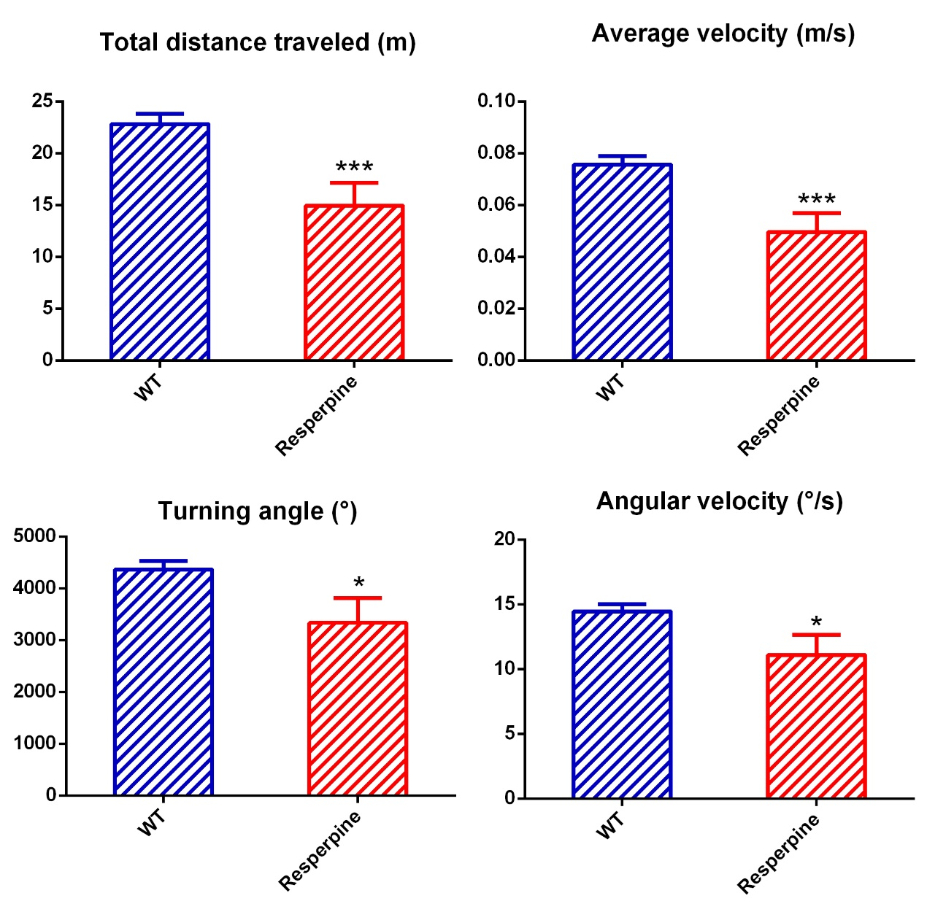
Figure 4. The locomotion behavior parameters of the wild type (WT) and the depressive (Reserpine) model. The total distance traveled, average velocity, angular velocity and turn angle and of zebrafish treated with reserpine decreased significantly compared with the wild types.

